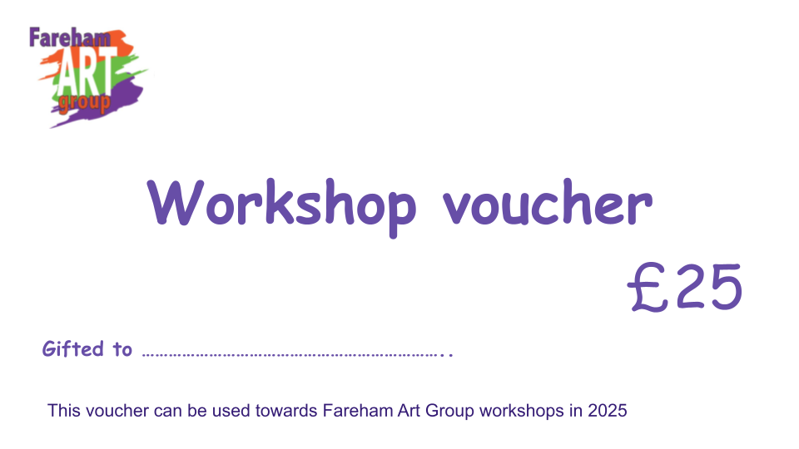
2027 Workshop Gift Vouchers

If your family and friends are short on gift ideas for you, why not suggest a Fareham Art Group Workshop Gift Voucher.
During 2027 Fareham Art Group will be offering a varied programme of workshops – as Tuesday afternoon sessions or full day Saturday workshops.
Please see the 2027 Events Programme or visit the website what's on
Family and friends can purchase a gift voucher towards the cost of a workshop which is redeemable when you book your place.
These vouchers can be any denomination from £10. All that is required is as follows:
The gifter sends an email to treasurerfarehamartgroup@gmail.com with the following information:
- Name of recipient (member)
- Value of voucher required.
- The gifter’s email address
- Pay the sum required online to Fareham Art Group
  - Sort code 40-21-03
  - Account number 21695592
Once the payment is received the voucher will be emailed to the gifter to download and give to the recipient

Alternatively we can email the voucher directly to the member with a message e.g Merry Xmas from ….

