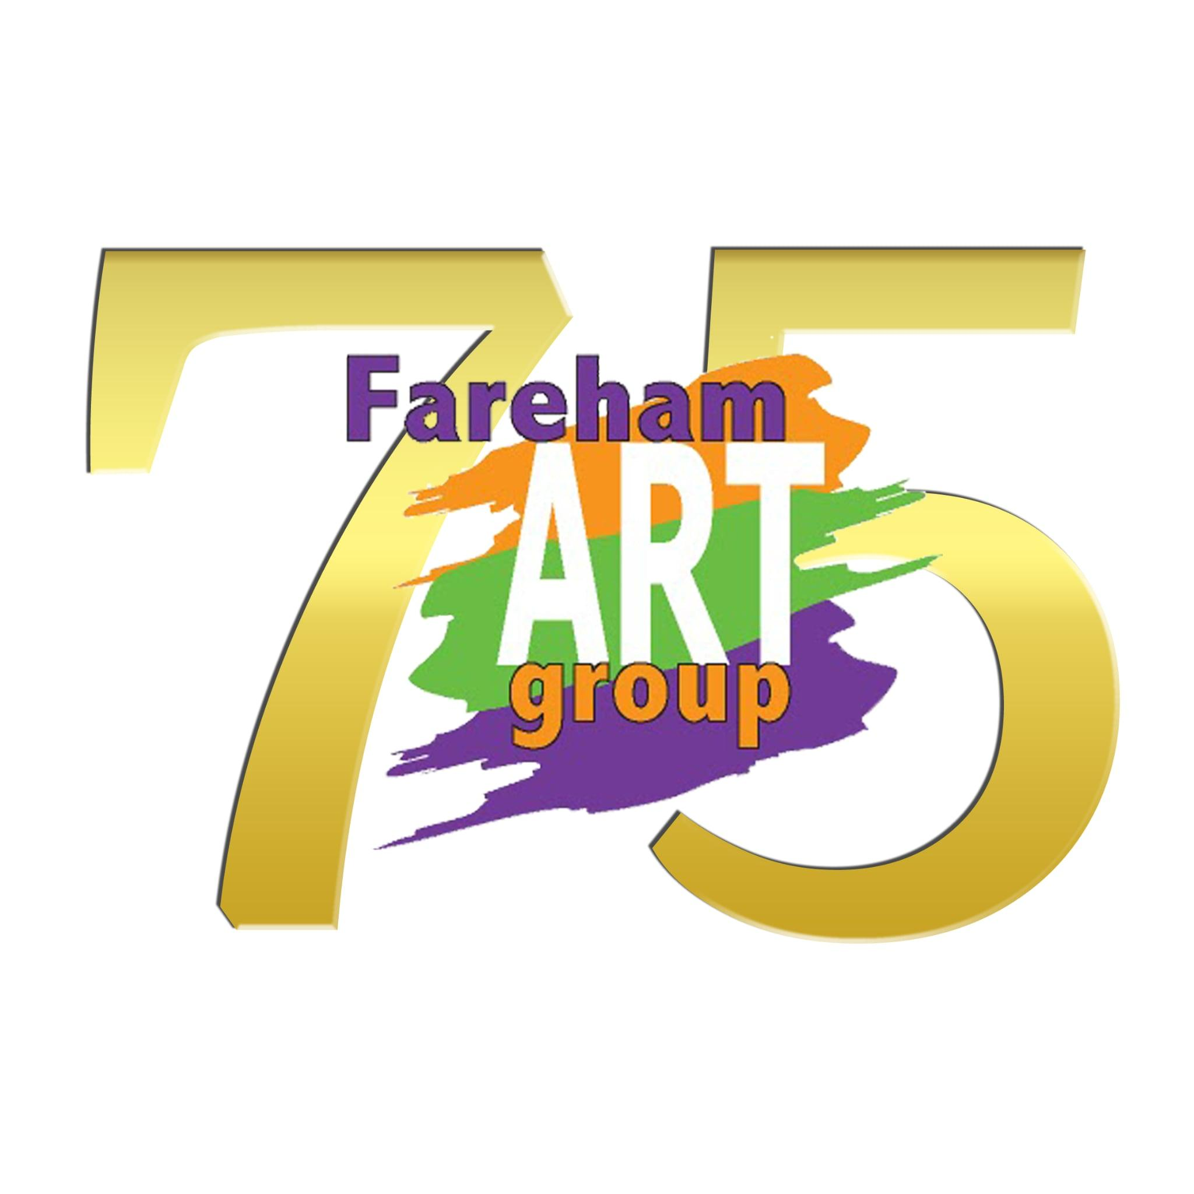

**Leaf Impressions Workshop**

**with Elizabeth Saunders**

**Tuesday afternoon workshop on Tuesday November 11th 2025 1.30 - 4pm**

**Cost £15, plus normal weekly fees**

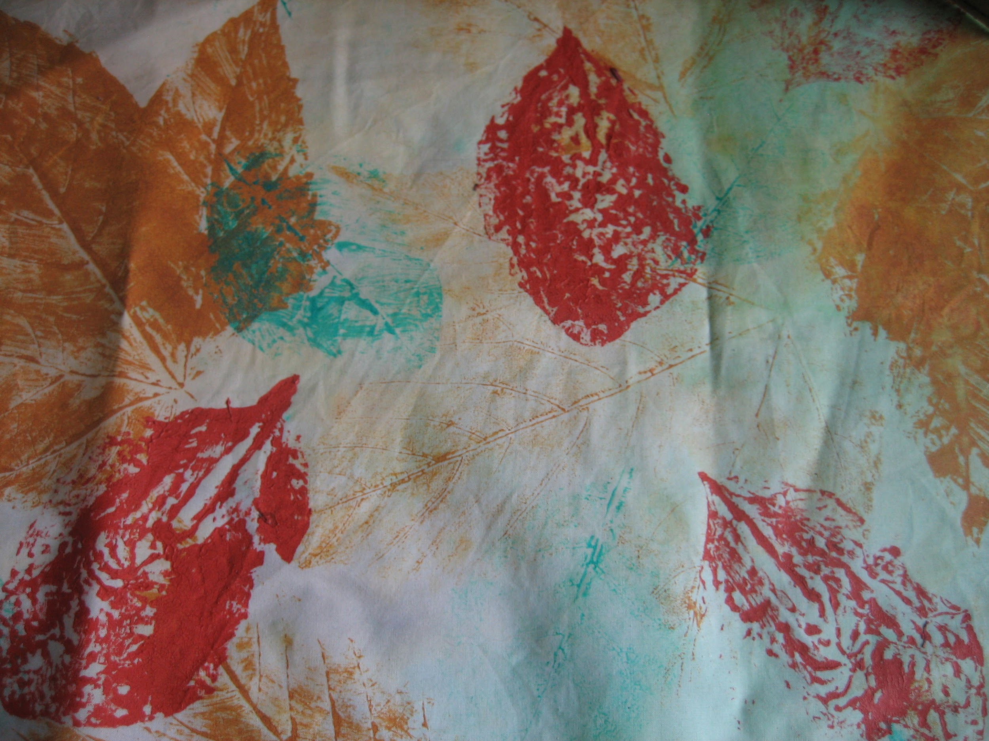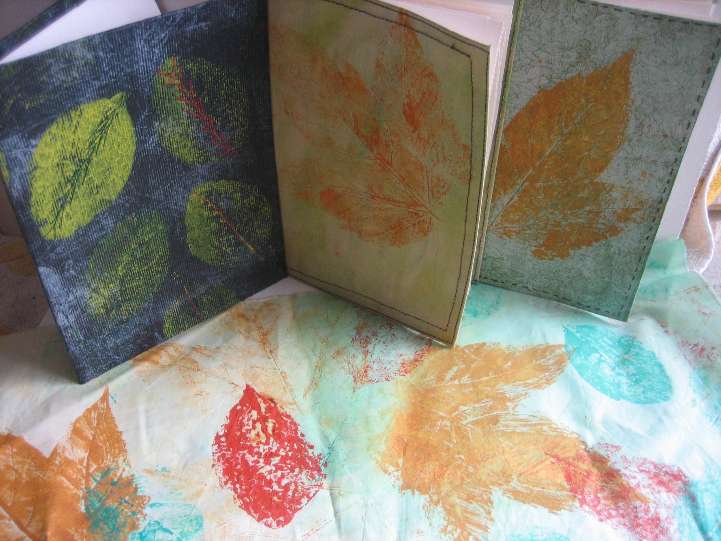

Elizabeth is a very popular artist and has demonstrated geli printing techniques to Fareham Art Group in the past. We are now pleased to be able to offer the opportunity to join her for an afternoon **printing with leaves onto fabric and paper to create a final journal cover using stitch.**

Discover printmaking with leaves in this enjoyable workshop with artist Elizabeth Saunders. Collecting a few leaves from the garden you will print with them using acrylic paint, fabric and paper. Creating several prints, you will then select one to create your cover for a journal, which you will be shown how to make. Exploring your own ideas and a variety of hand stitches you will use your leaf outlines to expressively stitch your cover. This workshop is suitable for beginners and the more experienced.

Elizabeth is a Textile Artist who works with paint, print and stitch within her work. Exhibiting her work within galleries and in National shows she continues to be influenced by historic and contemporary artists, finding motivating people about mixed media and textiles exciting and rewarding. She uses a variety of mixed media within her pieces of work. Often creating her work intuitively from her own drawings.

Elizabeth is Co-Founder of the exhibiting Textile Art Group Visual Marks set up in 2013 and recently set up the Three Rivers Textile & Embroidery Group in Chandlers Ford and Hampshire Art & Craft Collective exhibiting group.

Demand is likely to be high and places are limited. Booking is available via the on-line link included in this email. **To reserve your place on a first come basis full payment of £15 must be made** online to Fareham Art Group Sort Code 40-21-03 Account Number 21695592 or can be made in cash at the Tuesday sessions or via workshop voucher purchase.

If subsequently you cannot attend please give us as much notice and we may be able to fill your place, in which case a full refund will be given.

**Please note no confirmation of booking will be issued until approximately a month before the event, together with any workshop specific joining instructions, including suggested materials.**